Mathematical methods for quantitative finance

Week 1:

Discounting, the annuity, the perpetuity pricing formulas

The definition of the derivatie, the chain rule, and the product rule

Taylor series expansions

Week 1: limits and differentiation

Rules for evaluating limits

Rules for differentiation

I’Hospital’s rule

Simple interest

Compound interest

Discount factor

$$d_{k}=\frac{1}{{[1+(r/m)]}^{k}}$$

PV= $d_{k}$ FV

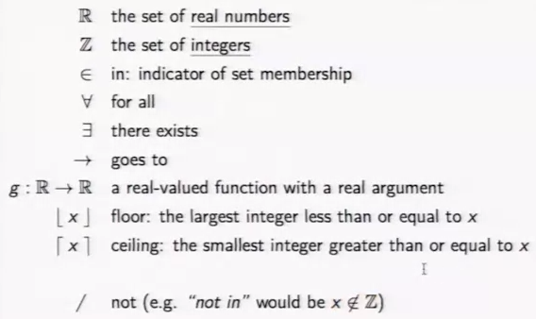

Limits

Rational function

Trigonometric function

Inverse trigonometric function

Root function

Exponential function

Logarithmic function

Product rule for derivative rule

Chain rule (Leibniz notation): dg/dx = dg/du du/dx

Bond duration

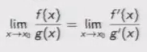

Week 2:

Integration: want to find area of the region

The fundamental theorem of calculus, the antiderivative

Probability density functions

Integration by Parts (product rule backward): idea: choose F(x) and g(x) so that integrate[f(x)G(X) is easy to compute], 降次 升次

Integration by substitution (chain rule backward)

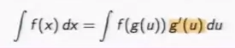

Completing the square

Differentiating definite integrals

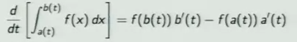

Improper integrals: infinite intervals and unbounded functions

Differentiate the improper integral: 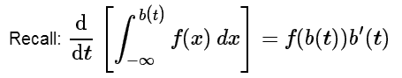

Week 3

Scalar valued functions

A function of several variables that takes values in R is called a scalar valued function.

Example: black-Scholes formula for a European Call Option Price

Inputs:

S: asset price, σ: asset volatility (unpredictability), K: strike price; r: risk-free interest rate, T: maturity, q: asset continuous dividend rate, t: time,





Partial derivatives

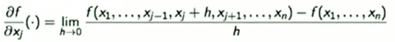

In practice, to compute partial derivative, fix x,k for k != j, then differentiate f as a function of one variable x,j

Let f(x) = f(x1,x2,x3,x4,…,xn), the gradient of f(x) is denoted by D f(x) and is defined to be the following 1 x n array of partial derivatives

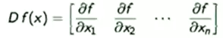

Vector valued functions

A function of one or several variables that takes values in a multidimensional space is called a vector valued function

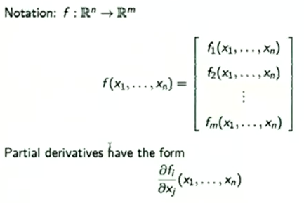

So there are n X m first-order partial derivatives in total.

Higher Order Partial Derivatives

Let f(x) = f(x1,x2,…,xn), the Hessian of f (x)is denoted by D2f(x) and is defined to be the following n X n array of (mixed) partial derivatives.

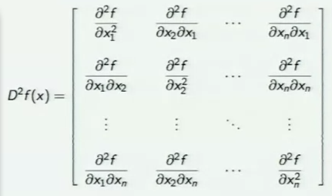

Functions of two variables

The partial derivatives of f are also functions of x and y:

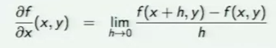

The gradient of f(x,y) is

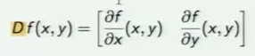

The hessian of f(x,y) is

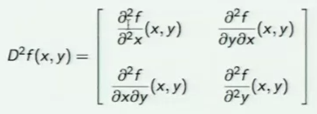

Chain rule for functions of a single variable

Chain rule for functions of 2 variables

Implicit functions

So far, functions have expressed one variable in terms of another, e.g.,

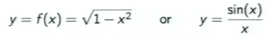

An implicit function is defined by a more general relation between the variables, e.g.,

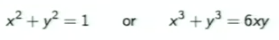

In some cases, possible to solve for one variable as an explicit function of the others.

Terminology: let F(x,y,z) be a function of 3 variables. The set of points that satisfy

F(x,y,z) = 0

Is called the locus defined by F.

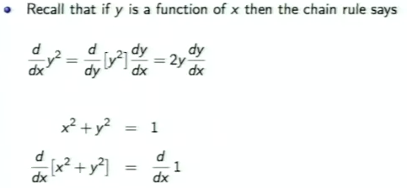

Put call parity and the greeks

Let V be the value of a portfolio of derivative securities based on one underlying asset

The rates of change of the value V wrt pricing parameters (e.g., asset price, volatility, etc.) useful for hedging.

These rates of change are called the Greeks of the portfolio

Consider a portfolio containing a single European call option

Price using Black-Scholes

S: asset price, σ: asset volatility (unpredictability), K: strike price; r: risk-free interest rate, T: maturity, q: asset continuous dividend rate, t: time,

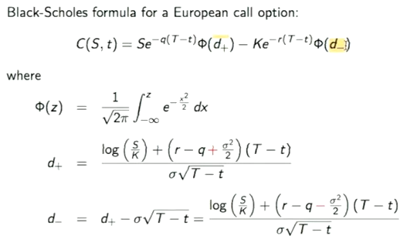

C(t) and P(t) are prices of European call and put options on the same asset, respectively. 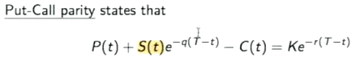

P(t) and C(t) are related

Derivatives of P(t) and C(t)

The Greeks

Delta (Δ): rate of change of C wrt S : $Δ= \frac{∂C}{∂S}$

Gamma (Γ): rate of change of wrt S: $Γ= \frac{∂Δ}{∂S}$

Theta (θ): rate of change of C wrt t: $θ= \frac{∂C}{∂t}$

Rho (ρ): rate of change of C wrt r: $ρ= \frac{∂C}{∂r}$

Vega: rate of change of C wrt σ: $vega= \frac{∂C}{∂σ}$

Delta

Delat (Δ) of a European call option is the rate of change of C(S,t) wrt the asset price S

$$Δ= \frac{∂C(S,t)}{∂S}$$

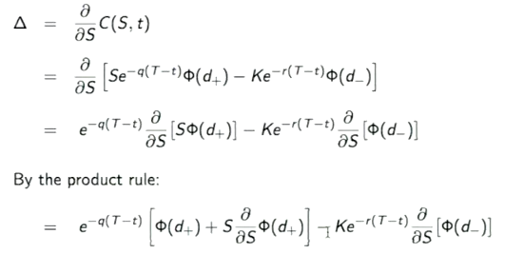

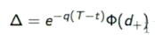

Gamma (Γ) is the derivative of Delta wrt S

$$Γ= \frac{∂Δ}{∂S}$$

Rho (ρ) is the rate of change of the value of the portfolio wrt the risk-free interest rate r

$$ρ= \frac{∂C}{∂r}$$

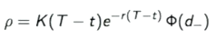

Vega is the rate of change of the value of the portfolio wrt the volatility σ

$$vega= \frac{∂C}{∂σ}$$

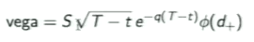

Theta (θ) is the rate of change of the value of the portfolio wrt the time t



Week 4

Double integrals

Fubini’s theorem

Change of variables for double integrals

Change of variables example

Double integrals of separable functions

Polar coordinates (R ant theta)

A culturally important integral

Marginal density of a bivariate normal distribution

Double integral: the volume of the region

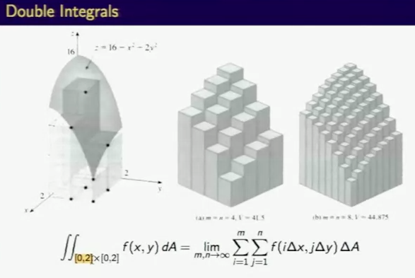

Partial differentiation

Partial integration

An iterated integral

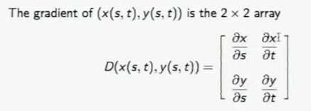

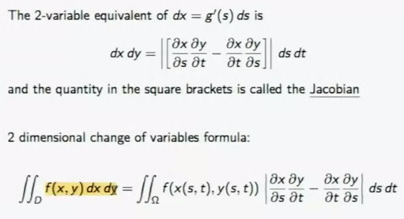

After changing variables, we need to find out the domain of the integration (s,t), using graph is good idea

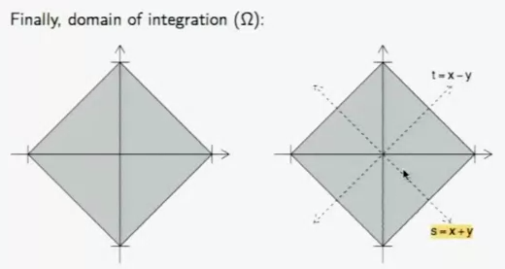

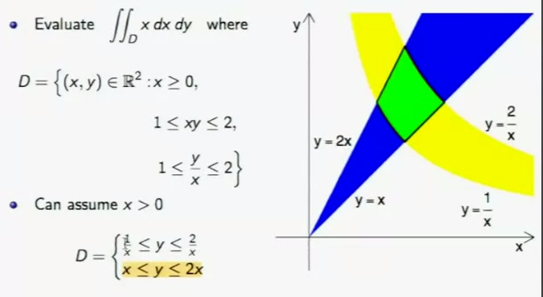

According to the D domain provided, draw the graph to find out the the region, which helps to do next:

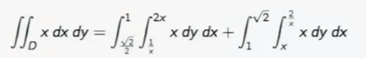

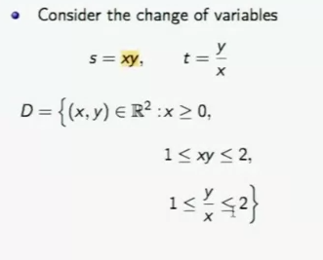

Polar coordinates

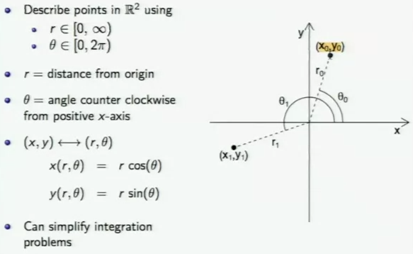

Change of variables to polar coordinates

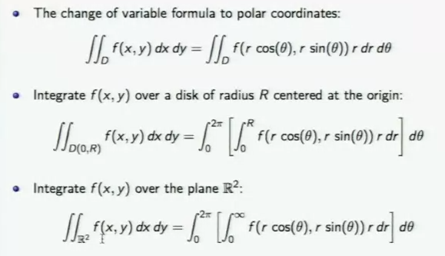

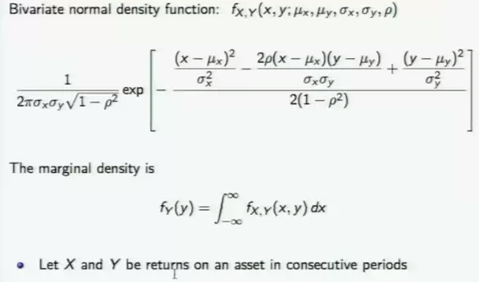

The marginal density is partial integral of the double integration

Week 5

Vectors

Vector length and planes

Systems of linear equations

Elimination

Matrix multiplication

Solving Ax = b

Inverse Matrices

Matrix Factorization

The R environment for statistical computing

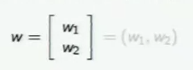

I prefer to put the vectors in column

Addition for vectors is defined component-wise

Doubling a vector

The vector is drawn as an arrow with the tail at the origin and the pointy end at the point

The dot product or inner product of u and w is the scalar quantity

The length of a vector

The zero vector

Unit vector

A unit vector has the same direction as the vector

Vector norms

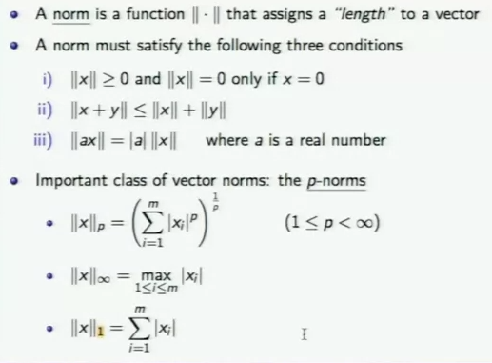

The dot product u w is zero when u is perpendicular to w

The vector u = (cos(theta), sin(theta)) is a unit vector

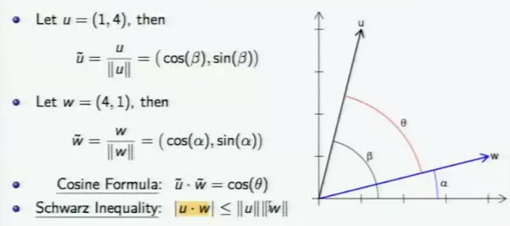

So far, 2-dimensional

Everything (dot products, lengths, angles, etc.) works in higher dimensions too

A plane is a 2-dimensional sheet that lives in 3 dimensions

Conceptually, pick a normal vector n and define the plane P to be all vectors perpendicular to n

Every plane normal to n has a linear equation with coefficients n1, n2, n3:

n1x +n2y + n3z = n1x0 + n2y0 + n3z0 = d

different values of d give parallel planes

systems of linear equations

want to solve 3 equations in 3 unknowns

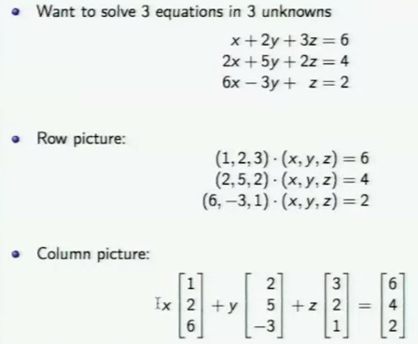

Use the rows to plot and the columns to do mathematicas

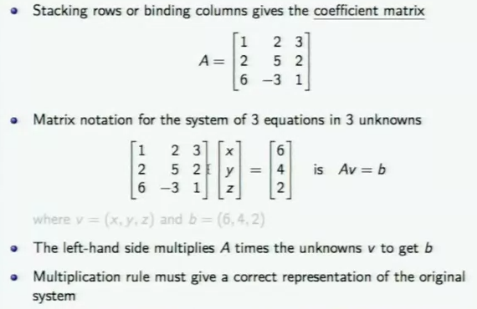

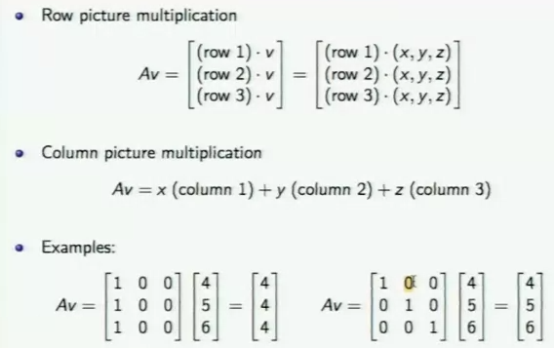

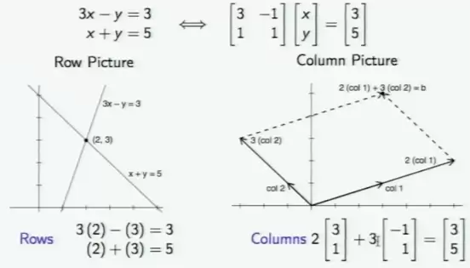

For an equal number of equations and unknowns, there is usually one solution

Not guaranteed, in particular there may be:

* No solution (e.g. when the lines are parallel)
* Infinitely many solutions (e.g., two equations for the same line)

Elimination

Pivot: the first nonzero in the equation (row) that does the elimination

Multiplier (number to eliminate) / (pivot)

Elimination: subtract a multiple of one equation from another

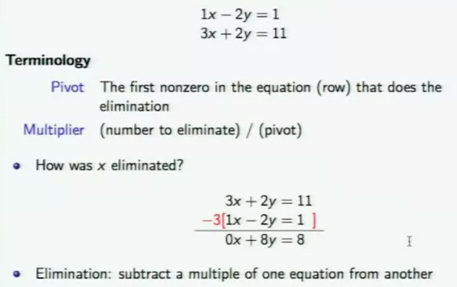

Idea is to use elimination to make an upper triangular system

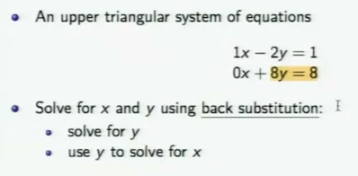

Elimination using matrices

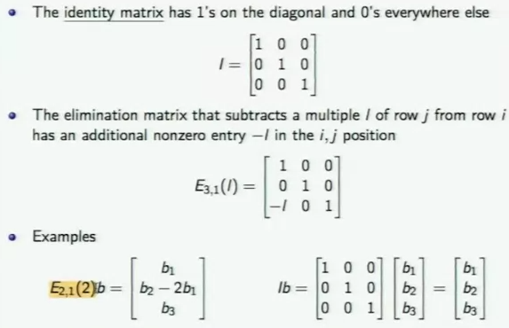

Matrix multiplication

A matrix is a rectangular array of numbers

An mxn matrix A has m rows and n columns

The entries are denoted by aij

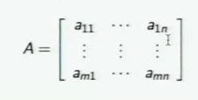

Matrices can be added when their dimensions are the same

A matrix can be multiplied by a scalar value c

Matrix multiplication is a bit more difficult

To multiply a matrix A times a matrix B

# columns of A = # rows of B

Let A be an m x n matrix and B an n x p matrix

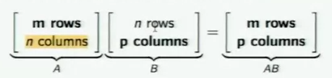

The dot product is extreme case, let u = (u1, u2) and w = (w1, w2)

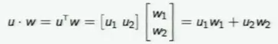

The matrix product AB contains the dot products of the rows of A and the columns of B

(AB)ij = (row i of A) (column j of B)

Matrix multiplication formula, let C = AB

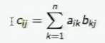

Computational complexity: {n myltiplications, n-1 additions} / cell

An inner product, which is a scalar value, is a row times a column

A column times a row is an outer product, which is a matrix

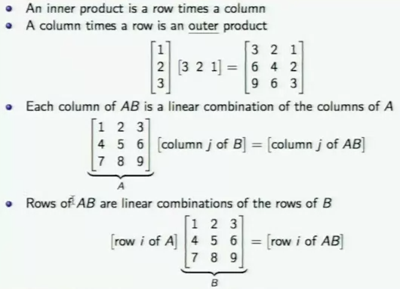

Laws for addition

A + B = B + A (commutative law)

C(A + B) = cA + cB (distributive law)

A + (B + C) = (A + B) + C (associative law)

C(A + B) = CA + CB (distributive law from left)

(A + B) C = AC + BC (distributive law from right)

The important thing is that if C comes first, then C has to come first

A(BC) = (AB) C (associative law; parentheses not needed)

Caveat: there is one law we do not get

AB != AB

BA exists only when p = m

If a is an m x n matrix and B is n x m, then AB is an m x m matrix, and BA is an n x n matrix

Even when A and B are square matices

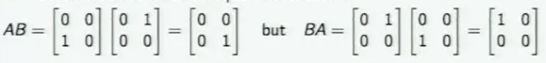

Square matrices always commute multiplicatively with cl

Matrix powers commute and follow the same rules as numbers

(Ap)(Aq) = Ap+q



Where I is the indentical matrix, and A has to be square matrices

A matrix may be broken into blocks (which are smaller matrices)

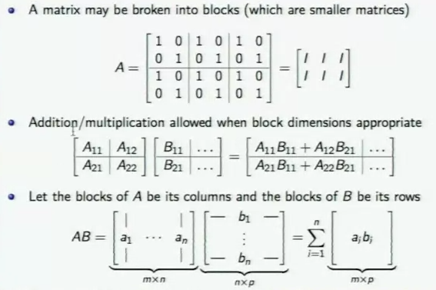

Solve Ax = b

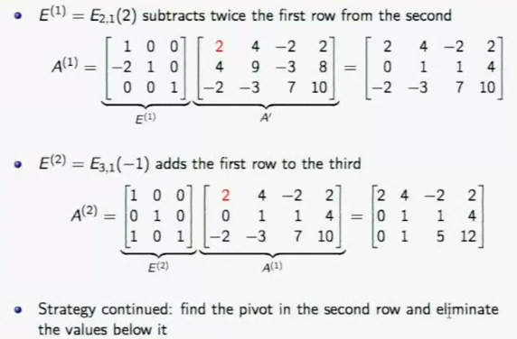

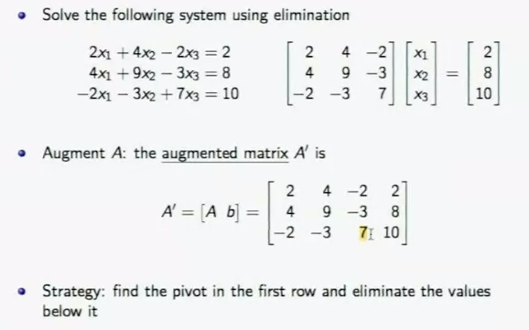

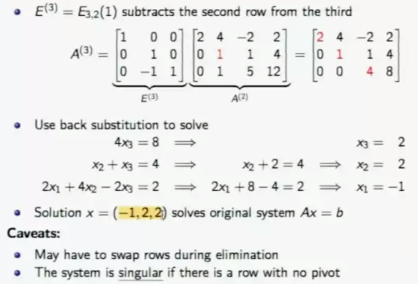

Inverse matrices

A square matrix A is invertible if there exists A-1 such that

A-1A = I and AA-1 = I

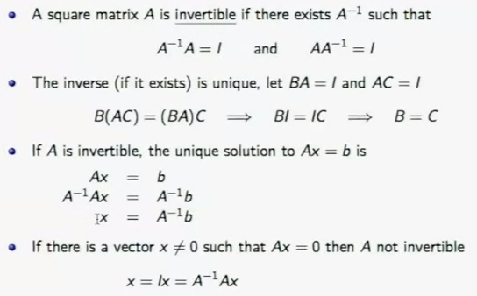

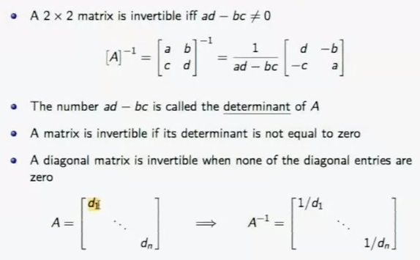

Inverse of a product

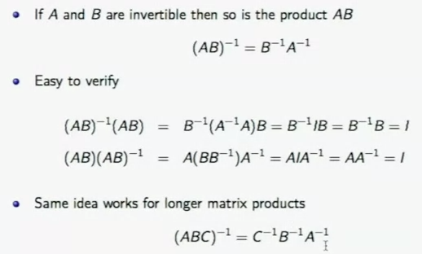

Calculation of A-1

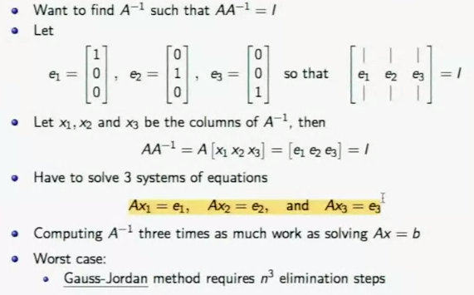

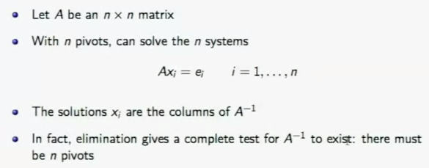

Matrix factorization

Elimination is one type of factorization

Key ideas in linear algebra ~ factorization of matrices

Look closely at 2 x 2 case

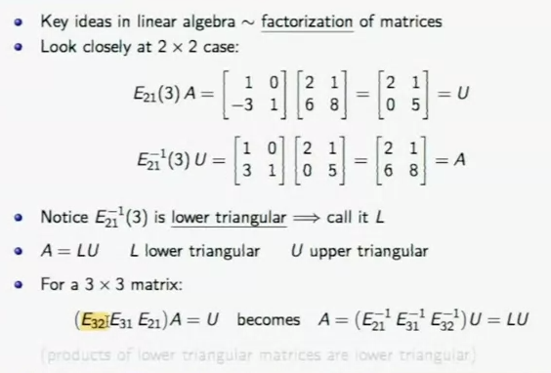

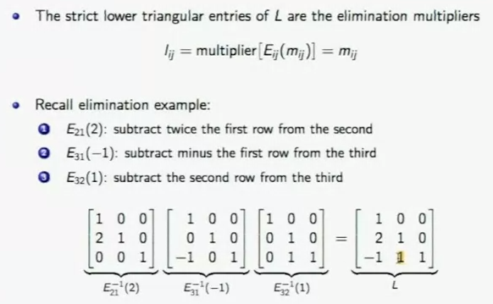

One square system = two triangle systems

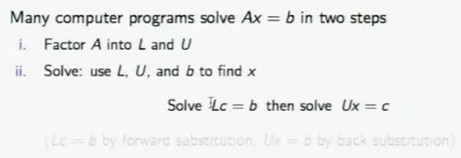

LU factorization

Elimination factors A into LU

The upper triangular U has the pivots on its diagonal

The lower triangular L has ones on its diagonal

L has the multiplier Iij below the diagonal

Computational cost of elimination

Let A be an n x n matrix

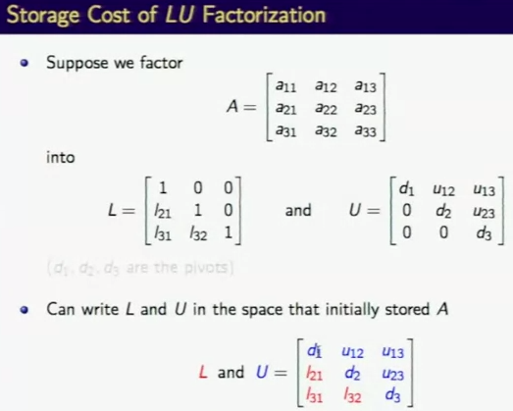

The R environment for statistical computing

R is a language and environment for statistical computing and graphics

R offers:

A data handling and storage facility

A suite of operators for calculations on arrays, in particular matrices

A well-developed, simple and effective programming language includes conditionals, loops, user-defined recursive functions, and input and output facilities

Creating matrices in R

Use the matrix function to shape a vector into a matrix

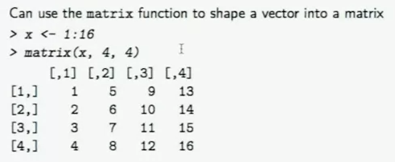

Use square brackets with 2 arguments (row, column) to access entries of a matrix

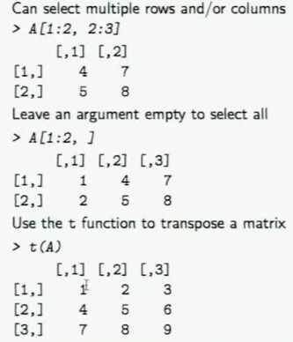

R always consider * to be component-wise multiplication

Dot product (scalar results), use the %*% function

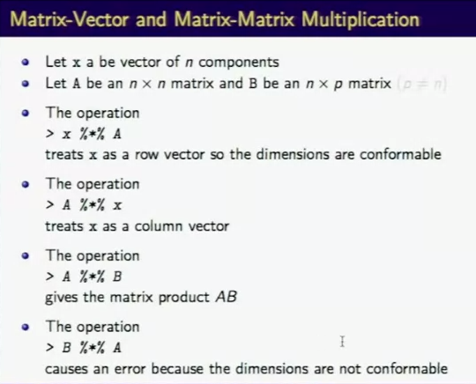

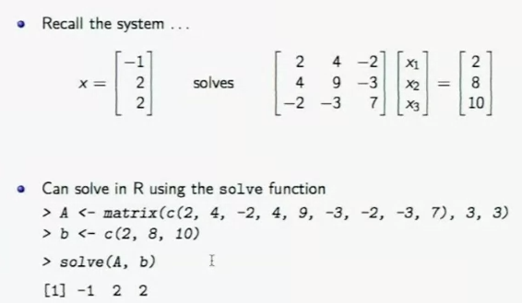

Week 6

Outline

Transposes and permutations

Vector spaces and sbuspaces

Variance-covariance matrices

Computing covariance matrices

Orthogonal matrices

Singular value factorization

Eigenvalues and eigenvectors

Solving least squares problems

Transposes

Let A be an m x n matrix, the transpose of A is denoted by AT

The columns of A are the rows of AT

If the dimension of A is m x n then the dimension of AT is n x m

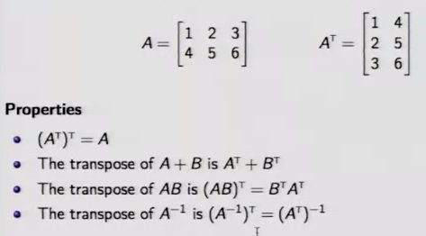

A symmetric matrix satisfies A = AT if A is a square matrix. It implies that aij= aji

A diagonal matrix is automatically symmetric

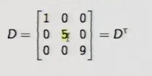

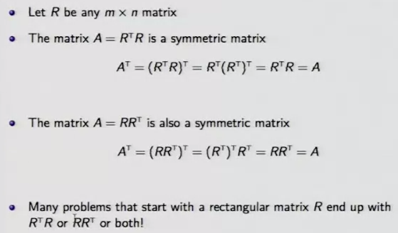

Permutation matrix

The properties of permutation matrix

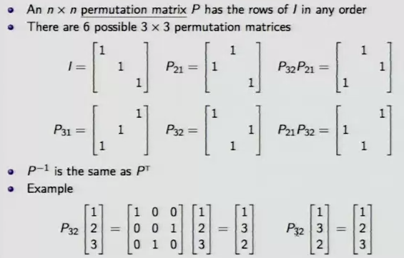

The space Rn consists of all column vectors with n components

For example, R3 all column vectors with 3 components and is called 3-dimensional space

The space R2 is the xy plane: the two components of the vector are the x and y coordinates and the tail starts at the origin (0,0)

Two essential vector operations go on inside the vector space

* Add two vectors in Rn
* Multiply a vector in Rn by a scalar

The result lies in the same vector space Rn

A subspace of a vector space is a set of vectors (including the zero vector) that satisfies two requirements:

If u and w are vectors in the subspace and c is any scalar, then

* u + w is in the subspace
* cw is in the subspace

L: any line through (0,0,0), e.g., the x axis

P: any plane through (0,0,0), e.g., the xy plane

R3: the whole space

Z: the zero vector

**The column space of A**

The column space of a matrix A consists of all linear combinations of its columns

The linear combinations are vectors that can be written as Ax

Ax = b is solvable if and only if b is in the column space of A

Let A be an m x n matrix

The columns of A have m components

The columns of A live in Rm

The column space of A is a subspace of Rm

The column space of A is denoted by R(A), where R stands for range

**The Nullspace of A**

The nullspace of A consists of all solutions to Ax = 0

The nullspace of A is denoted by N(A)

Example: elimination

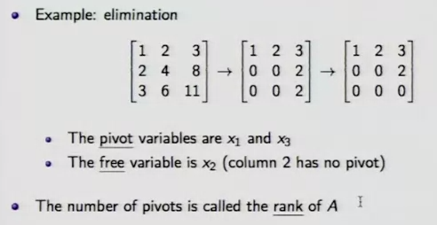

A variable is a basic variable if it corresponds to a pivot column. Otherwise, the variable is known as a free variable. In order to determine which variables are basic and which are free, it is necessary to row reduce the augmented matrix to echelon form.

A rectangular matrix is in **echelon form** if

1. All nonzero rows are above any rows of all zeros.
2. Each leading entry of a row is in a column to the right of the leading entry of the row above it.
3. All entries in a column below a leading entry are zero.

The matrix is in **reduced echelon form** if it satisfies the above requirements and also

1. The leading entry in each row is one.
2. The entries above each leading entry are zero as well.

Examples (x represents any nonzero entry, while * represents any entry):

|  |  |  |  |  |
| --- | --- | --- | --- | --- |
| x | * | * | * | * |
| 0 | 0 | 0 | x | * |
| 0 | 0 | 0 | 0 | 0 |

is in echelon form, while

|  |  |  |  |  |
| --- | --- | --- | --- | --- |
| 1 | * | * | 0 | * |
| 0 | 0 | 0 | 1 | * |
| 0 | 0 | 0 | 0 | 0 |

is in reduced echelon form.

A variable is a **basic variable** if it corresponds to a *pivot column*.   Otherwise, the variable is known as a **free** **variable**.  In order to determine which variables are basic and which are free, it is necessary to *row reduce* the*augmented matrix* to [echelon form](http://www.sci.wsu.edu/math/faculty/hudelson/echelon.html).

For instance, consider the system of linear equations

       x1 + 2x2 - x3     = 4  
      2x1 -  4x2           = 5

This system has the *augmented matrix*

|  |  |  |  |
| --- | --- | --- | --- |
| 1 | 2 | -1 | 4 |
| 2 | -4 | 0 | 5 |

which row reduces to

|  |  |  |  |
| --- | --- | --- | --- |
| 1 | 2 | -1 | 4 |
| 0 | -8 | 2 | -3 |

This last matrix is in [echelon form](http://www.sci.wsu.edu/math/faculty/hudelson/echelon.html), so we can identify the *pivot positions* (the locations in red.)  The first and second columns are *pivot columns*, so variables x1 and x2 are basic variables.  The third column is not a   
*pivot column*, so x3 is a free variable.   Finally, the last column is not a *pivot column*, so the system is *consistent*.

non-pivot columns are those containing free variables and pivot columns are those containing the basic variables.

The number of pivot columns corresponds to the rank of the system, which is also the number of basic variables.

Linear independence

A sequence of vectors v1, v2, …, vn is linearly independent if the only linear combination that gives the zero vector is 0v1 + 0v2 + … + 0vn

The columns of A are independent if the only solution to Ax = 0 is the zero vector

* Elimination produces no free variables
* The rank of A is equal to n
* The nullspace N(A) contains only the zero vector

a set of vectors spans a space if their linear combinations fill the space

a basis for a vector space is a sequence of vectors that

* are linearly independent
* span the space

the dimension of a vector space is the number of vectors in every basis

Variance-covariance matrices

Let x, y be vectors of length m

Sample covariance of x and y

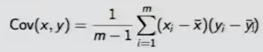

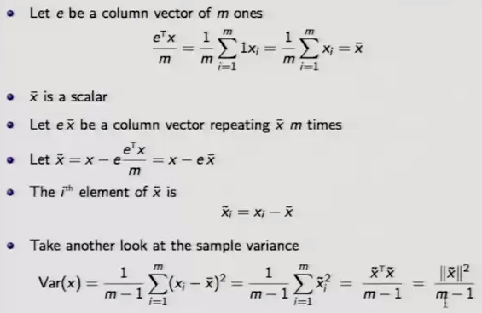

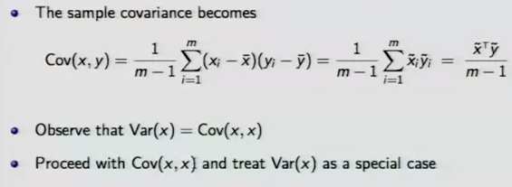

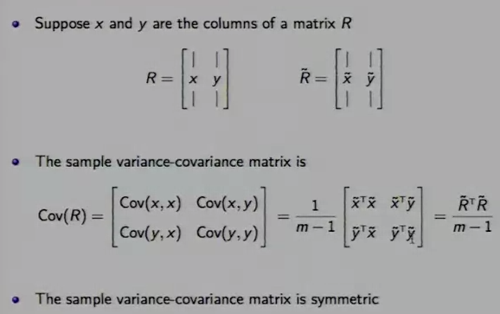

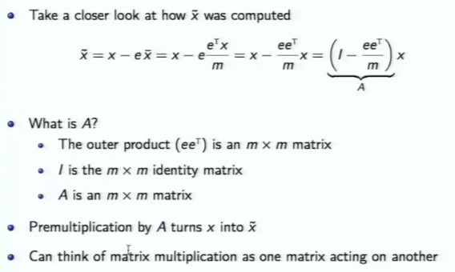

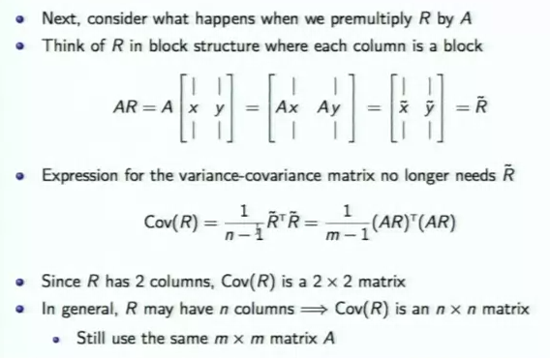

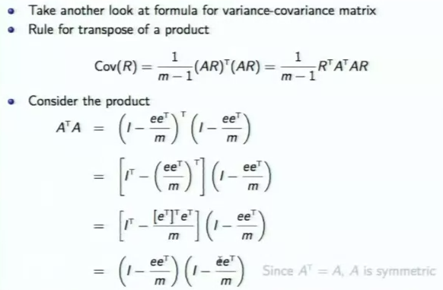

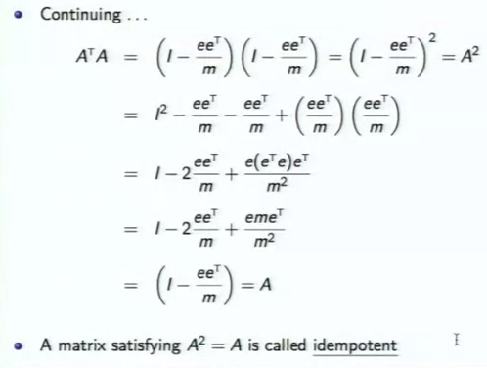

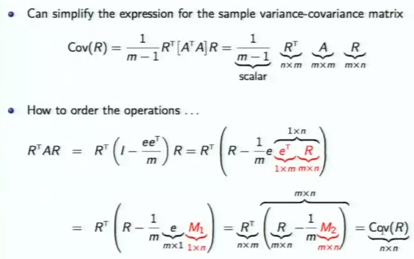

Orthogonal matrices

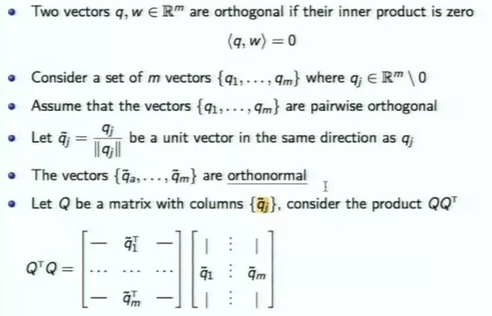

The inner product of the two vectors is zero, so they are orthogonal. If they are orthogonal, they are linearly independent.

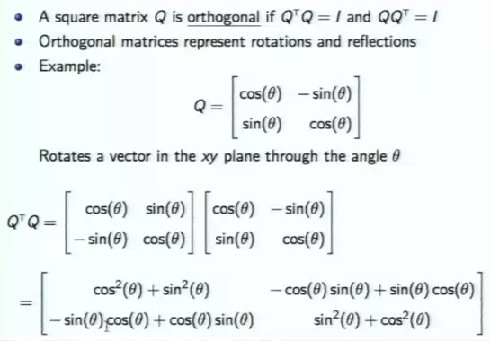

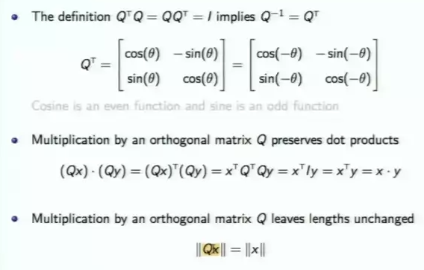

Singular value factorization

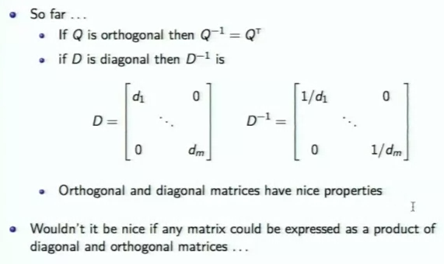

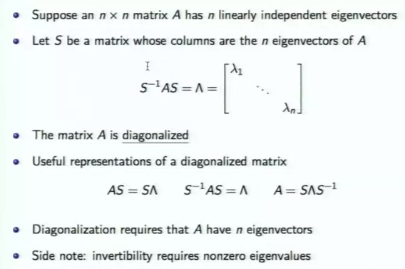

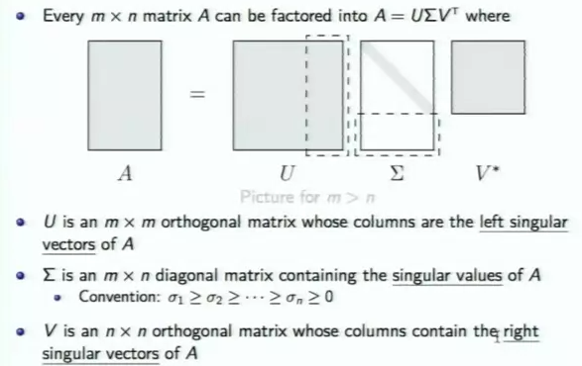

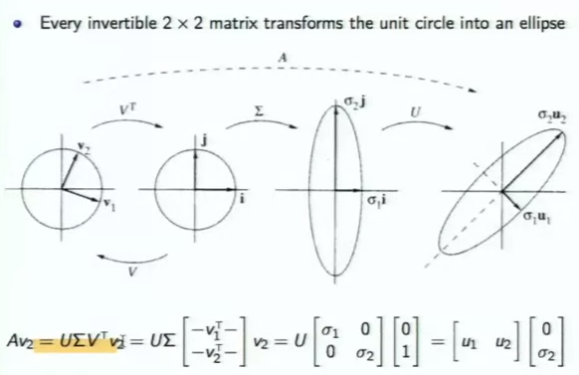

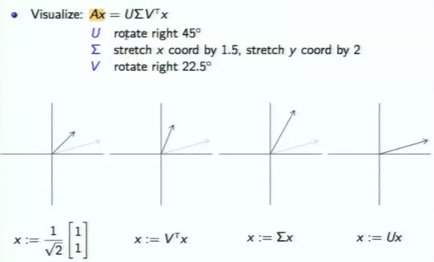

Notes: W6.6 singular value factorization, not quite understood, need practice

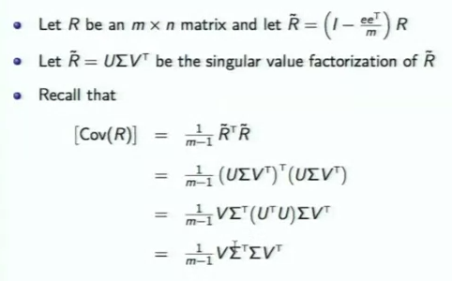

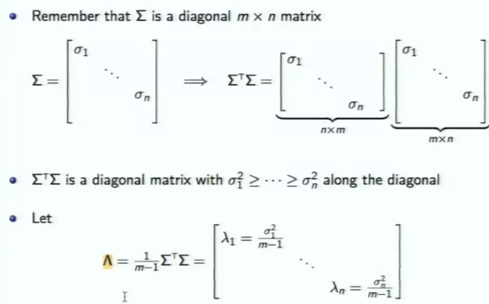

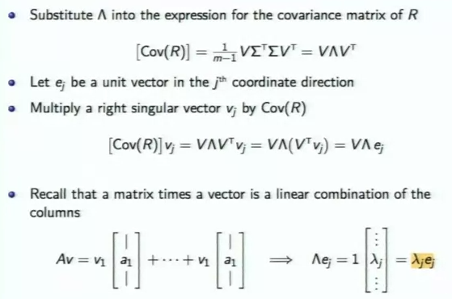

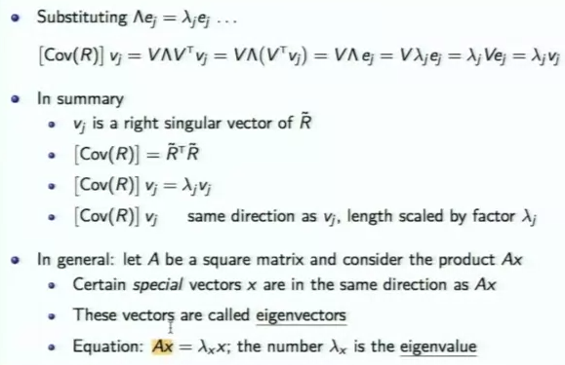

Eigenvectors are orthorganol?

Invertibility?

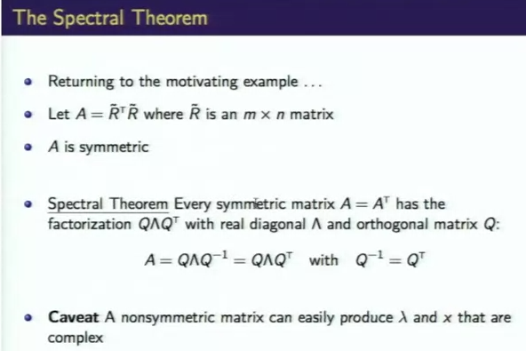

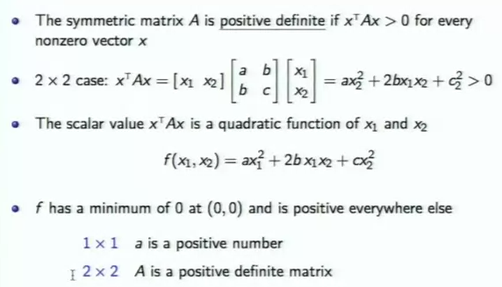

Solve least squares

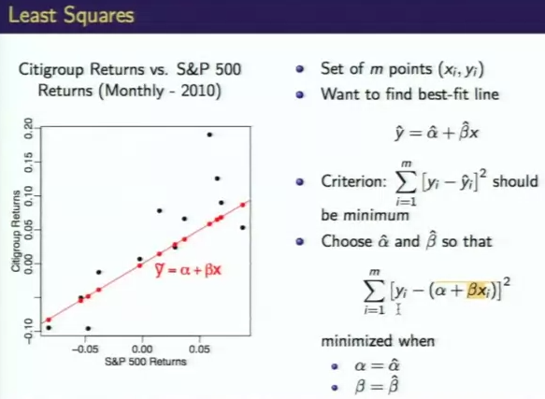

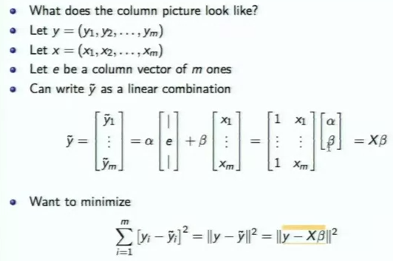

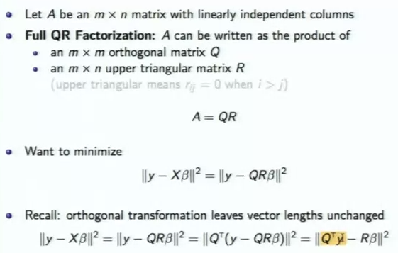

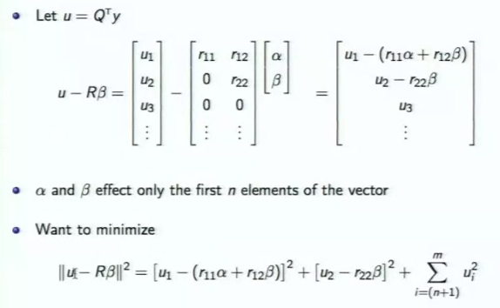

Lagrange’s method and taylor series

Optimal investment portfolios

Relative extrema of functions of several variables

Lagrange’s method

Example

Minimum variance portfolio

Taylor’s formula for functions of one variable

Big O notation

Taylor’s formula for functions of seeral variables

Taylor series expansions

Bond convexity

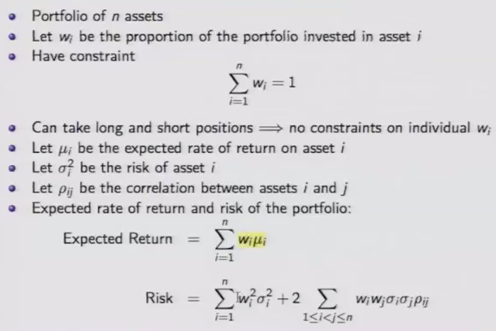

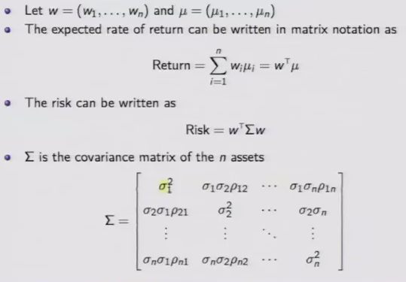



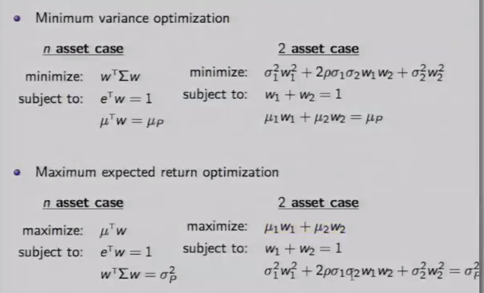

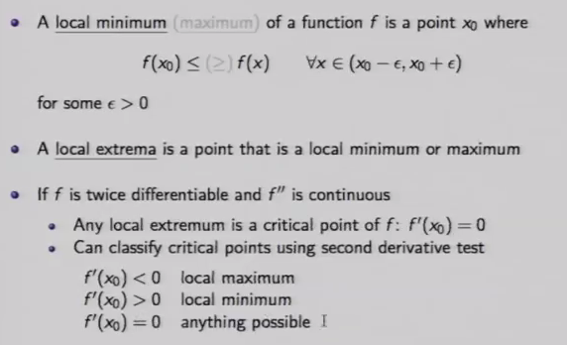

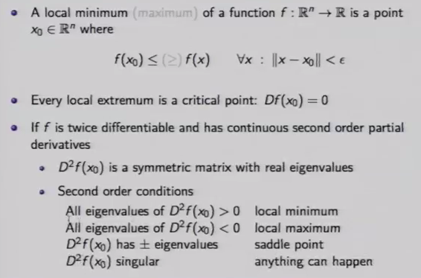

A singular matrix is a square matrix that its determinant is 0, which means that it does not have a matrix inverse.

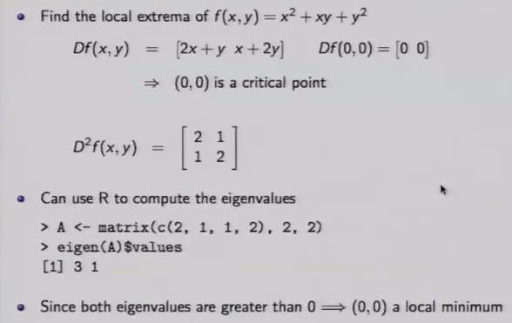

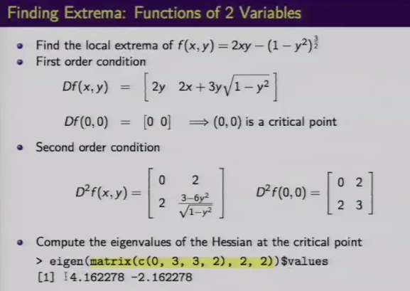

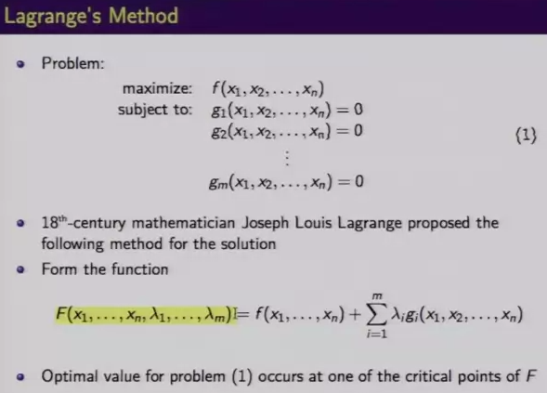

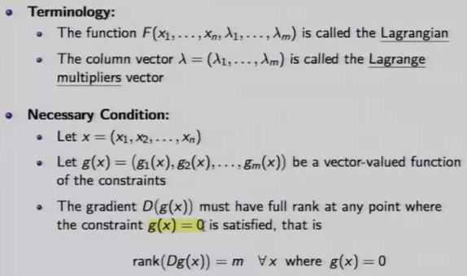

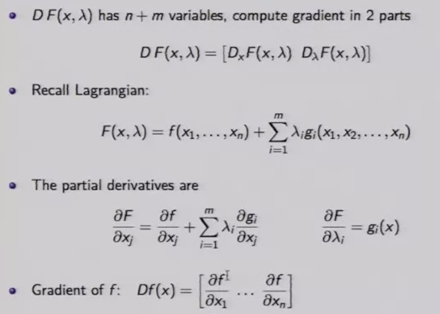

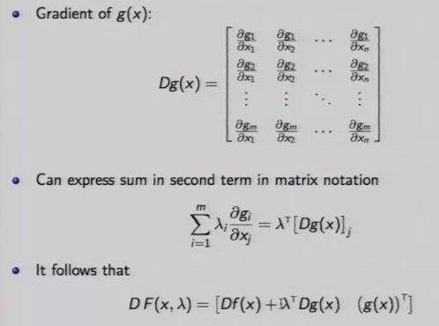

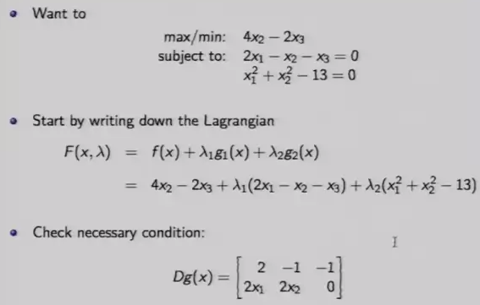

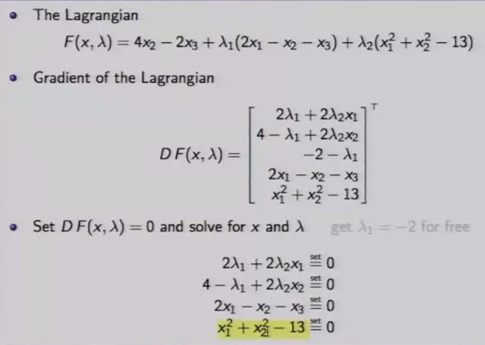

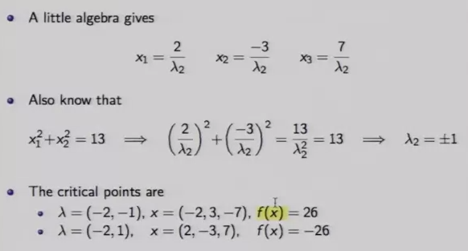

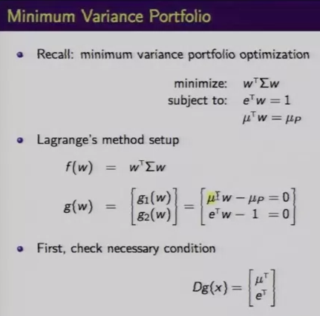

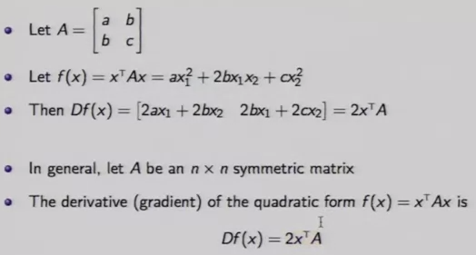

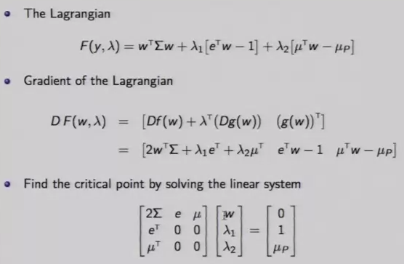

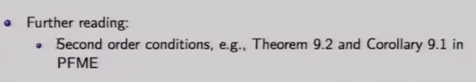

Taylor’s formula for functions of one variable

Taylor series expansions

Bond convexity

Big O notation

Taylor’s formula for functions of several

